**Software Engineering Challenge**

**Requirements**

Describe the challenge or problem, what does the program need to do

What classes/objects do you think you need?

How much time do you think you will you need to complete the project?

1. Cityscape

At least one building class

City class

Complex class

1. Multiple Buildings

Windows

1. Animate

Blinking windows

Moving the sun across the sky

**Research**

What knowledge or skills will you need to build this program

I need to know how to use applets and use my problem solving abilities

What examples are online or in other graphical programs (games, apps etc. . .)

Cityscapes made by previous students

If so, what can you learn from them?

How to structure my city

Do you foresee any problems or constraints, describe

Animation might be tough for me

Have you created a similar programs or applets? Are there similar programs in the book or other resources?

In class

If so, what elements of that project can you bring to this project?

Pretty much everything

Do you have the resources you need to create the program?

BUCKY!!!

Do you need to learn any new knowledge or skill(s) to create the program?

Just what I learned in class

**Design**

Draw/create a basic graphic of the applet you plan to build - attach the drawing

(paint, word, photo shop) not every objet (draw one example although there may be several in the final program) needs to be in the basic graphic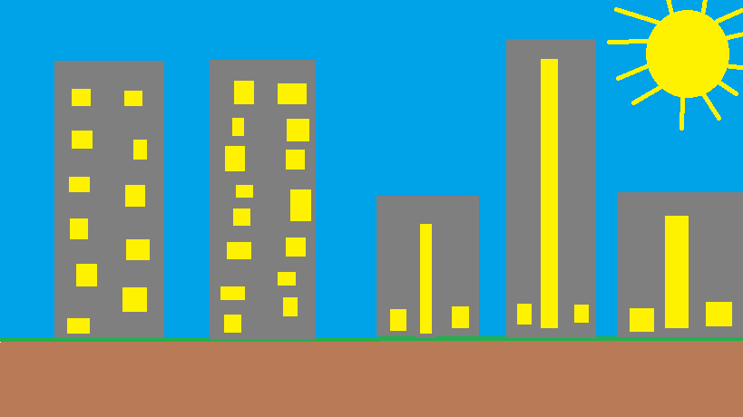

Include a task list--what will you need to do and in what order

* Create all the methods and applets I want to use
* Start by creating the background

Estimate the amount of time you will need to complete the project

2 Weeks

January 19, 2017

**Construction – included in summary doc**

Document your construction progress with date and progress made (build a chart/table in word or excel), also, include at least three screen shots of your applet (beginning, middle, and end)

**Testing/Results/Delivery—summary doc not required to start project**

Preliminary testing

Does your program meet the needs of the initial challenge or problem? How do you know?

Are any changes or modifications needed, why or why not? Document any changes.

Summarize the project - what worked, what didn’t work, note your successes and/or failures.

Looking back, would you have done anything differently, why or why not

Software Summary Document

Daily Progress Report

|  |  |
| --- | --- |
| Date | Description |
| January 19, 2017 | Started a sketch of my graph. I wanted to do something basic and simple but I will try and make it more advanced afterward |
| January 20, 2017 | Finished sketch and this document. I made it very simple. I’m going to use a lot of animations and maybe throw in some cars or something |
| January 23, 2017 | Started creating applets. Messed up so I tried doing a component |
| January 24,  2017 | Gave up on component and went back to the applet. Created the ground and getting started on creating buildings |
| January 25,  2017 | Finished making buildings in my Building class. Then I started working on my sun and I made it but I’ve been having trouble making it move through the sky |
| January 26, 2017 |  |